US-Mexico trade smashes monthly record at nearly $95B

Noi Mahoney, Thursday, September 10, 2026
Original Article: https://www.freightwaves.com/news/us-mexico-trade-smashes-monthly-record-at-nearly-95b
Articles Reproduced by Permission of FreightWaves

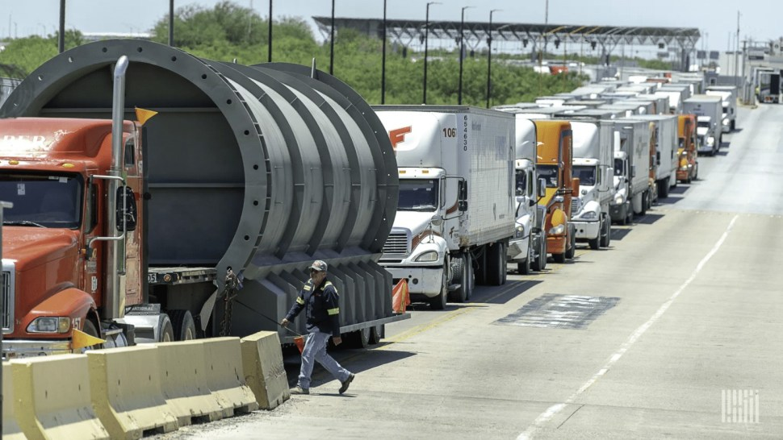
Through the first seven months of 2026 U.S.-Mexico trade totaled $588.52 billion, while Laredo, Texas, maintained its status as the top U.S. international trade gateway in July. (Photo: Jim Allen/FreightWaves)

Mexico remained the United States’ largest trading partner in July as two-way commerce surged 27.5% year over year

U.S.-Mexico trade reached a record $94.8 billion in July, the highest monthly total on record, according to U.S. Census Bureau data analyzed by WorldCity.

Two-way trade between the U.S. and Mexico increased 27.5% from $74.36 billion in the same month last year.

Mexico accounted for nearly 18% of the United States’ $530.37 billion in total international trade during the month. U.S. exports to Mexico totaled $34.24 billion, up 18.1% year over year, while imports from Mexico jumped 33.5% to $60.55 billion.

Canada ranked as the United States’ No. 2 trading partner in July at about $62.8 billion, followed by China at No. 3 with $36.8 billion in two-way commerce.

Mexico’s position atop the rankings comes as overall U.S. trade continues to expand. The United States recorded $530.37 billion in international commerce during July, including $197.45 billion in exports and $332.92 billion in imports.

Through the first seven months of 2026, U.S. trade with the world reached $3.51 trillion, up 6.2% from the same period last year. Mexico, Canada and China also held the top three positions among U.S. trading partners year to date, followed by Taiwan and Vietnam.

Mexico-U.S. commerce totaled $588.52 billion through July, up 16.1% year over year. U.S. exports to Mexico increased 16.6% to $229.82 billion, while imports from Mexico rose 15.8% to $358.71 billion.

The figures underscore Mexico’s growing importance to U.S. supply chains at a time when trade relationships with other major partners are being reshaped by tariffs and shifting sourcing patterns.

Laredo remains No. 1 US trade gateway
Laredo, Texas, retained its position as the nation’s busiest international trade gateway in July, handling $36.95 billion in two-way commerce.

Trade through Laredo increased nearly 22% from $30.29 billion a year earlier. Exports through the South Texas gateway rose 16.5% to $12.46 billion, while imports climbed 25% to $24.48 billion.

Chicago O’Hare International Airport was the No. 2 ranked U.S. gateway for trade in July at $36 billion, while the Port of Los Angeles was No. 3 at $26.5 billion.

Mexico accounted for the overwhelming majority of Laredo’s business. U.S.-Mexico trade moving through the gateway totaled $35.9 billion in July, up 21.9% year over year.

Laredo’s July performance also represented its strongest July on record in WorldCity data going back to 2013.

Automotive freight remained a major component of the gateway’s outbound traffic. Motor vehicle parts were Laredo’s No. 1 export commodity in July at $1.31 billion, up 19.2% year over year. Diesel engine exports jumped nearly 85% to $433.8 million, while motor vehicle engine exports increased 21% to $284.7 million.

Laredo is experiencing tight capacity, according to SONAR, a freight market analytics and data platform. As of Wednesday, the Laredo Van Outbound Tender Rejection Index is at 11.18%, indicating that securing trucking capacity in the market can be a challenge for shippers.

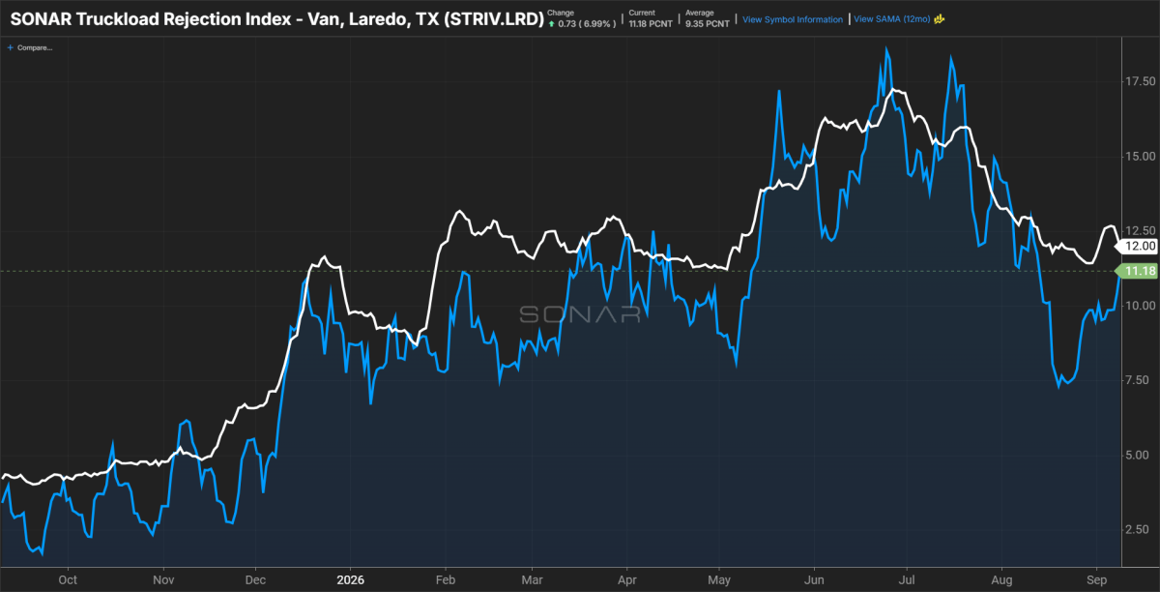
The SONAR VAN Tender Rejection Index for Laredo (STRIV.LRD) is currently at 11.18%, indicating carriers hold negotiating leverage due to limited capacity.

Why it matters: Nearly $95 billion in monthly commerce highlights the growing weight of Mexico in U.S. manufacturing and supply chains, while Laredo’s record July reinforces its role as the primary gateway for cross-border freight.

